

Final Year B. Tech (EE)

Trimester: X

Subject: AIML

Name: Shreerang Mhatre

Roll No: 52

Class: Ty

Batch: A3

Experiment No: 02

Name of the Experiment: Create and view custom neural networks


Marks Teacher’s Signature with date

Performed on: 24/08/2023

Submitted on: 31/08/2023

Aim: To create and view custom neural networks.

Prerequisite: Knowledge of NN tool in MATLAB, MLP, Activation function.

Objective:

To create and study the Neural Network by varying parameters.

- Define Input and Output Variable

- Define and custom Neural Network

- Define Transfer Function

- Configure the network
- Train the network to find output

Components and Equipment required:

MATLAB with NNTool Box

AMP/WPU/AIML/2020 |  |  |  | Expt. 1- 1
 |  |  | WWW.MITWPU.COM

Theory:

Neural networks are a set of algorithms, modelled loosely after the human brain, that are designed to recognize patterns. They interpret sensory data through a kind of machine perception, labelling or clustering raw input. The patterns they recognize are numerical, contained in vectors, into which all real-world data, be it images, sound, text or time series, must be translated. Neural networks help us cluster and classify.
In this sense, neural networks refer to systems of neurons, either organic or artificial in nature. Neural networks can adapt to changing input; so the network generates the best possible result without needing to redesign the output criteria. The concept of neural networks, which has its roots in artificial intelligence, is swiftly gaining popularity in the development of trading systems.
A neural network contains layers of interconnected nodes. Each node is a perceptron and is similar to a multiple linear regression. The perceptron feeds the signal produced by a multiple linear regression into an activation function that may be nonlinear.
In a multi-layered perceptron (MLP), perceptrons are arranged in interconnected layers. The input layer collects input patterns. The output layer has classifications or output signals to which input patterns may map.
Hidden layers fine-tune the input weightings until the neural network’s margin of error is minimal. It is hypothesized that hidden layers extrapolate salient features in the input data that have predictive power regarding the outputs.
Procedure
Step-1
Define and custom network
Define input and output/ Target variable
Assign input and target data

AMP/WPU/AIML/2020 |  |  |  | Expt. 1- 2
 |  |  | WWW.MITWPU.COM


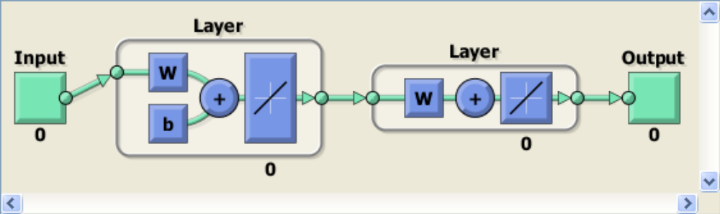

Step-2

Define topology and transfer function

No. Of hidden layers and their neurons

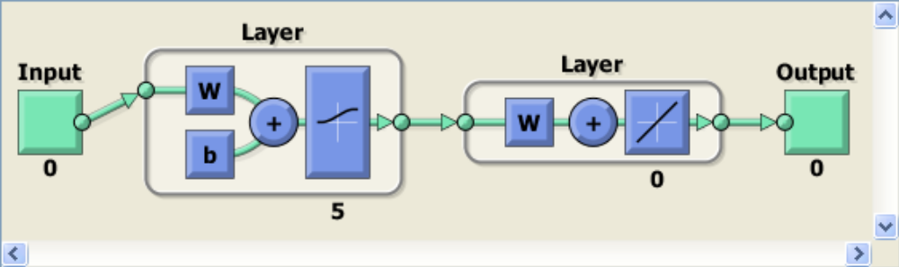

Step-3

Configure and view network

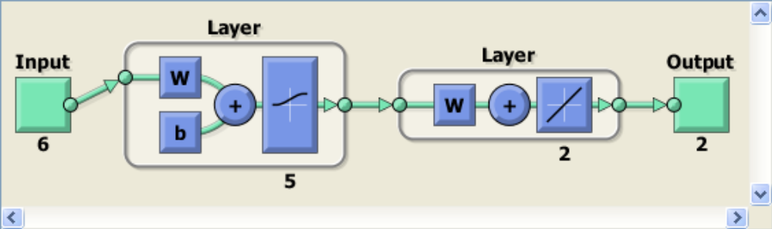

AMP/WPU/AIML/2020 |  |  |  | Expt. 1- 3
 |  |  | WWW.MITWPU.COM

Step-4

Train net and calculate neuron output

Observations:

Change the training parameters and view the performance.

Performance Plot

Training Graph

Regression Curves

MATLAB Output:

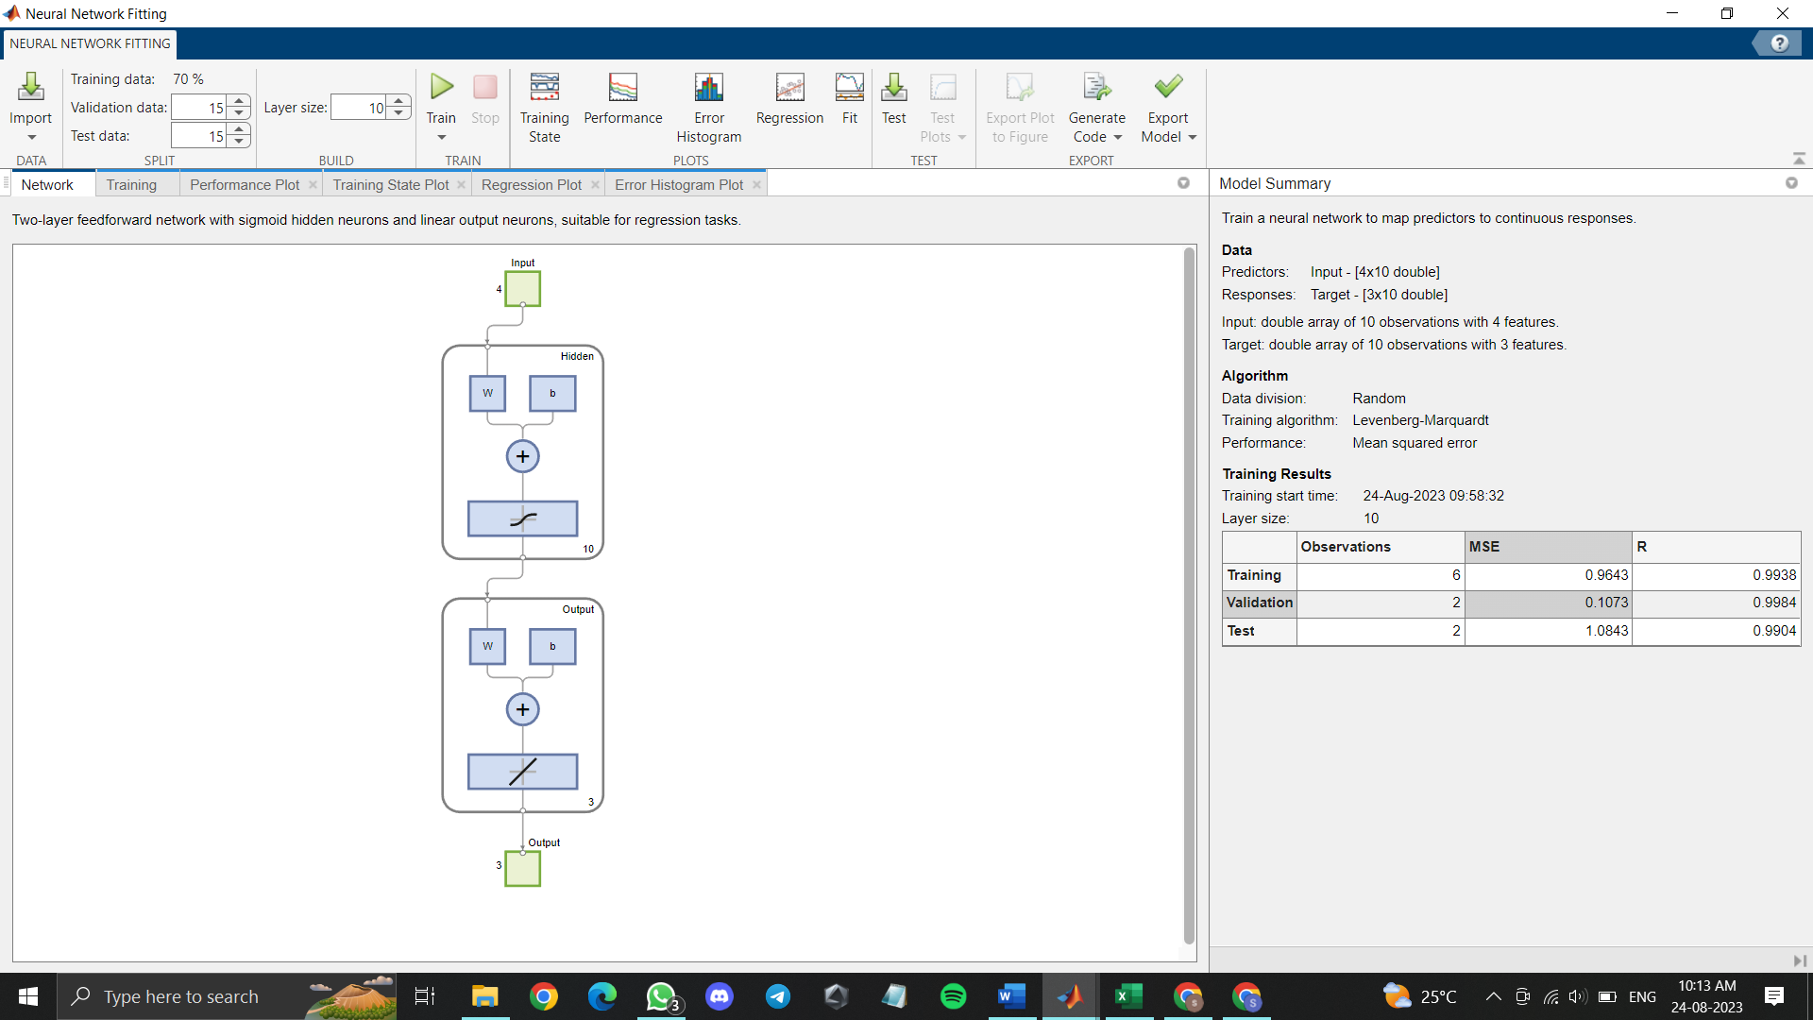

AMP/WPU/AIML/2020 |  |  |  | Expt. 1- 4
 |  |  | WWW.MITWPU.COM

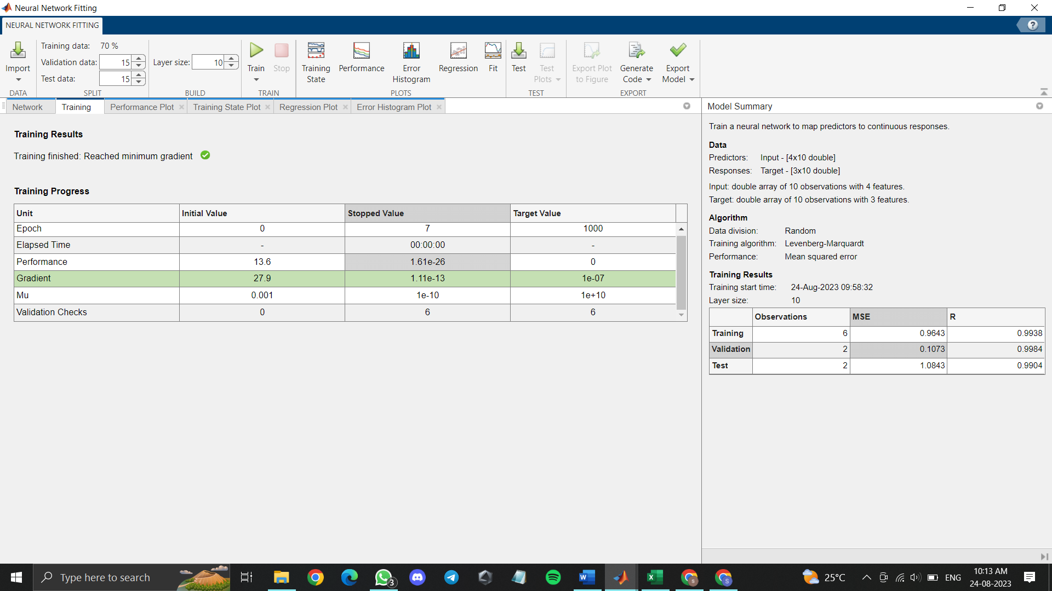

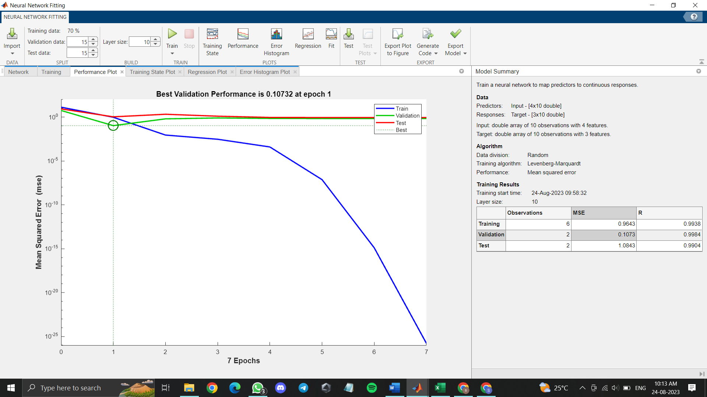

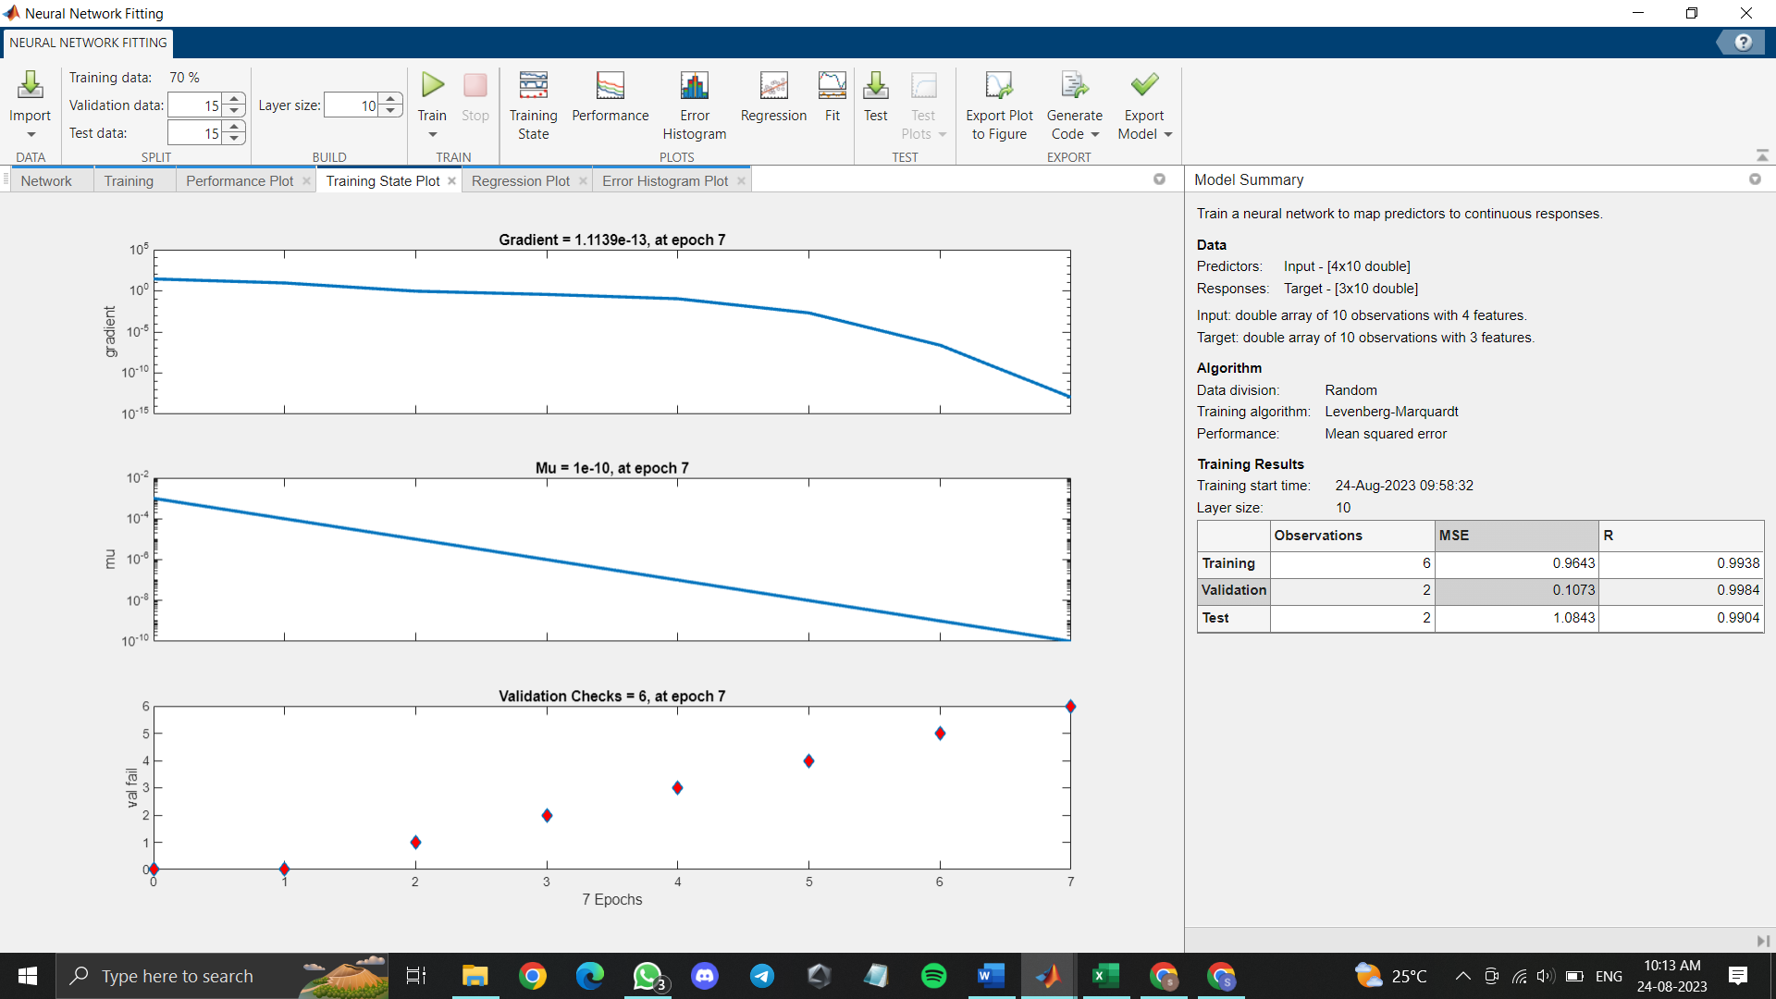
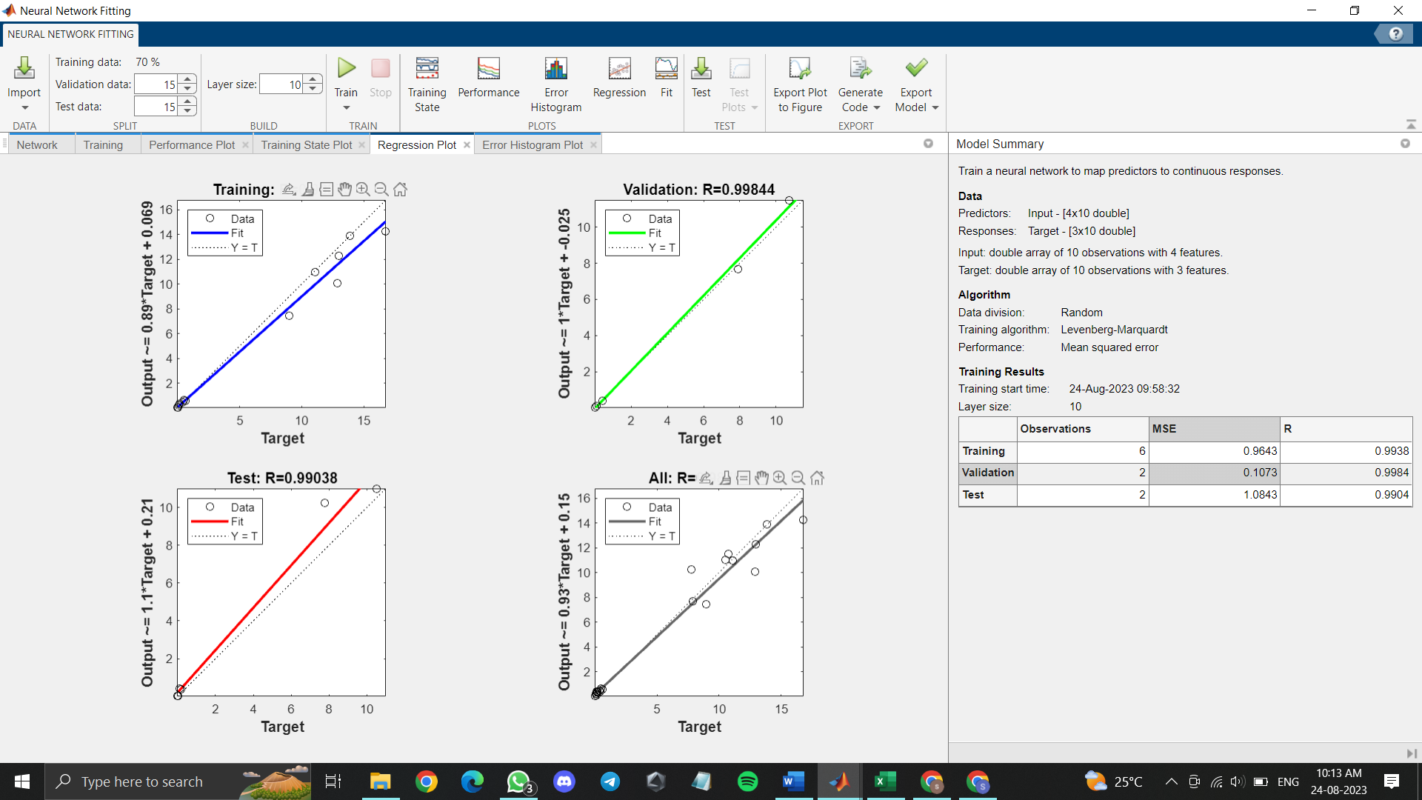


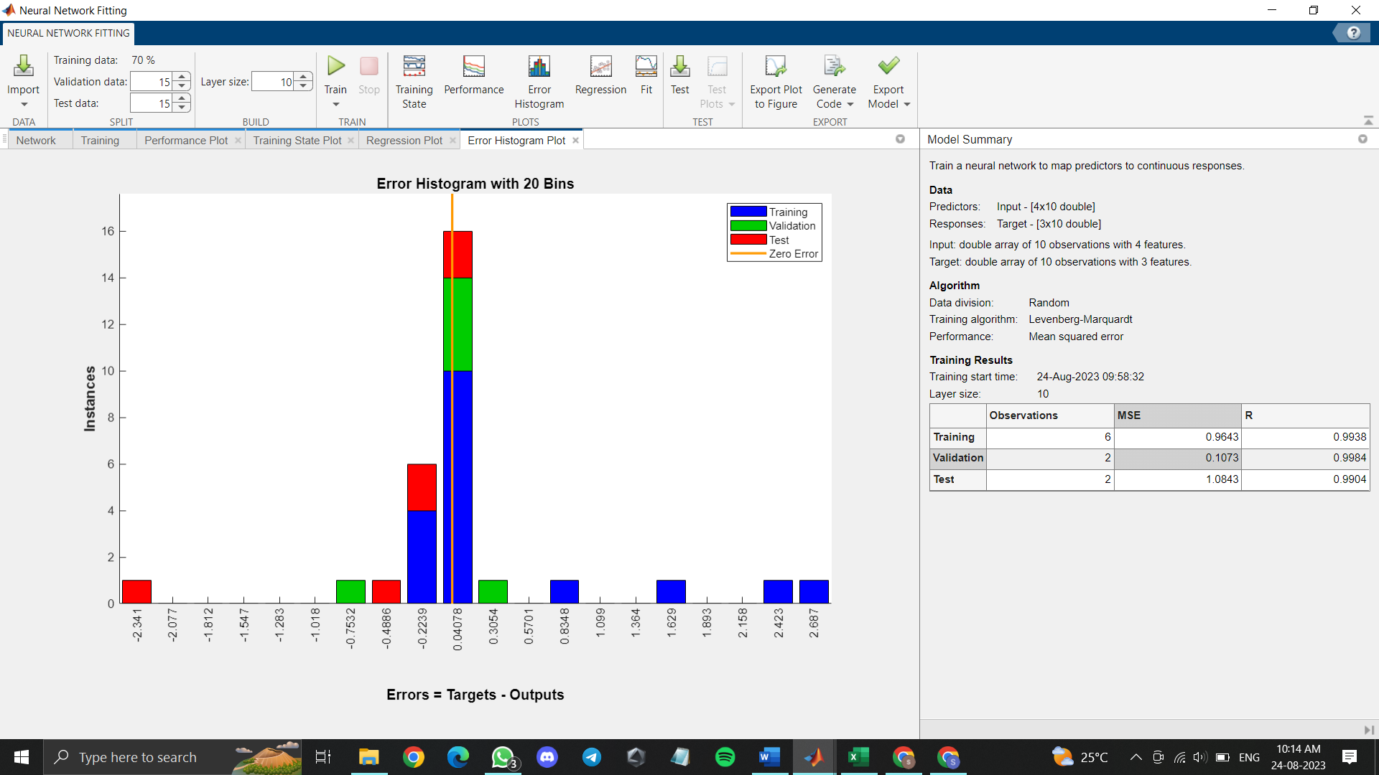

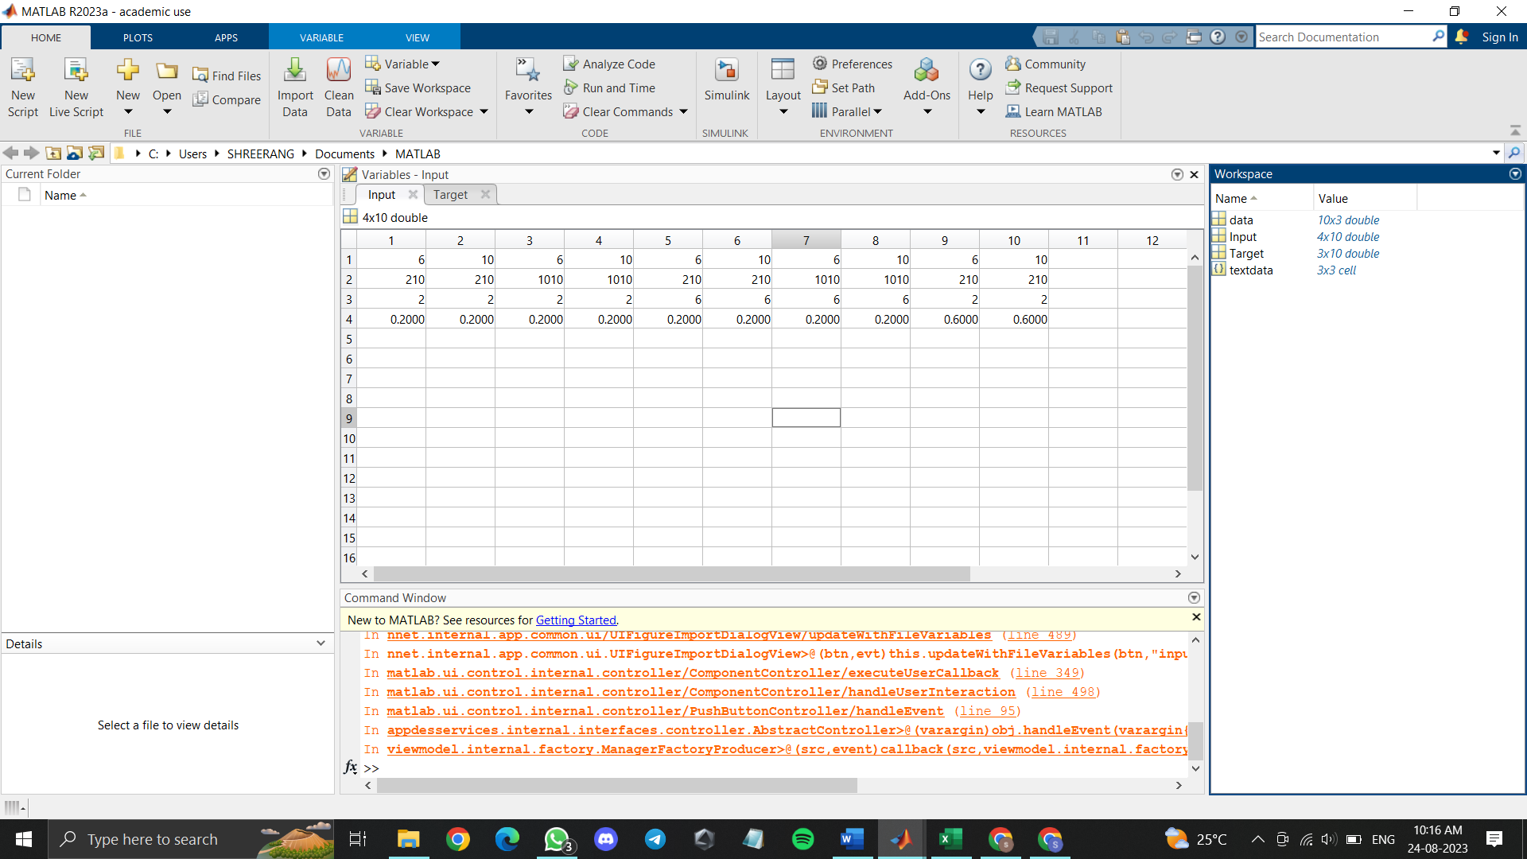

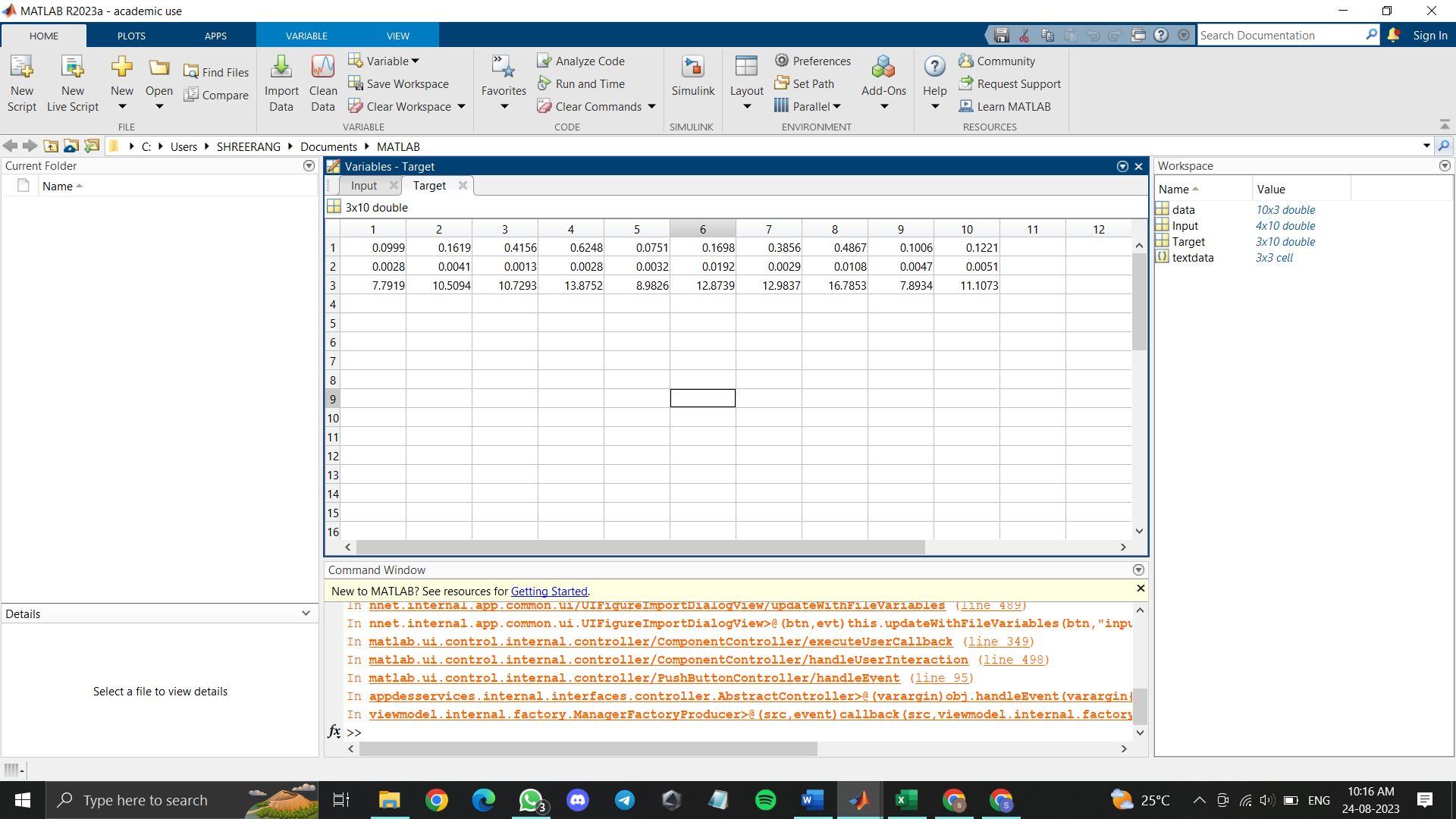

Conclusions:

Post Lab Questions:

AMP/WPU/AIML/2020 |  |  |  | Expt. 1- 8
 |  |  | WWW.MITWPU.COM

